Coding Challenge Day 3 (Week 1) - 2Q
-By galeti mohammad hussain

# Problem Statement

Coding Challenge Day 1 (Week 3)
# Student Management Spring 2
## Problem Statement
Spring Flowers school wants to manage their students online:-
## User Stories :-
1. As a Student, I should be able to see TimeTable button on the menu as well.
2. As a Student. I should be able to see my Time Table after clicking the TimeTable button.
3. As a student. I should be able to Open and see my school application on mobile.
## Instructions:-
1. Please reuse the application created in spring 1
2. Please use HTML 5 and CSS 3 concepts
3. Try to make a proper application
4. Deploy the application on http server
5. Please make sure the application should Responsive
6. Please use flex box to arrange the content.
7. Use Bootstrap to beautify the layout for eg: TimeTable , button etc.

Solution:

HTML code:

<!DOCTYPE html>
<html lang="en">
<head>
<meta charset="UTF-8">
<title>Spring Flowers School</title>

<!-- Bootstrap CDN -->
<link href="https://cdn.jsdelivr.net/npm/bootstrap@5.3.2/dist/css/bootstrap.min.css" rel="stylesheet">

<style>
body {
background-color: #f2f2f2;
}

.header-bar {
background-color: #295170;
padding: 15px;
}

.logo-container {
display: flex;
align-items: center;
gap: 10px;
}

.school-logo {
width: 45px;
height: 45px;
}

.school-name {
font-size: 26px;
font-weight: bold;
}

.profile-section,
.timetable-section {
display: none;
}

.profile-box,
.timetable-box {
background-color: #3e784a;
padding: 25px;
border-radius: 8px;
}

.student-image img {
width: 150px;
border-radius: 50%;
}
</style>
</head>
<body>

<header class="header-bar d-flex justify-content-between align-items-center">

<div class="logo-container">
<img src="https://tinyurl.com/logo12873546" class="school-logo">
<span class="school-name">Spring Flowers School</span>
</div>

<div>
<button class="btn btn-dark me-2" onclick="showHome()">Home</button>
<button class="btn btn-dark me-2" onclick="showProfile()">Student Profile</button>
<button class="btn btn-dark" onclick="showTimeTable()">TimeTable</button>
</div>

</header>

<div class="container mt-4">

<div id="homeSection">
<h2 class="text-center">Welcome to Student Management System</h2>
</div>

<div id="profileSection" class="profile-section">
<div class="profile-box d-flex flex-column flex-md-row align-items-center gap-4">

<div class="student-image">
<img src="https://tinyurl.com/studentimage4">
</div>

<div class="student-info">
<h2>Student Information</h2>
<p><strong>Name:</strong> HUSSAIN</p>
<p><strong>Class:</strong> 10th Grade</p>
<p><strong>Roll No:</strong> 30</p>
<p><strong>Email:</strong> hussain7@gmail.com</p>
<p><strong>9th standard marks:</strong> 85%</p>
</div>

</div>
</div>

<div id="timetableSection" class="timetable-section">
<div class="timetable-box">

<h4 class="text-center mb-3">Time Table</h4>

<table class="table table-bordered table-striped text-center">
<thead class="table-dark">
<tr>
<th>Day</th>
<th>9-10</th>
<th>10-11</th>
<th>11-12</th>
<th>1-2</th>
</tr>
</thead>
<tbody>
<tr>
<td>Monday</td>
<td>Math</td>
<td>English</td>
<td>Science</td>
<td>History</td>
</tr>
<tr>
<td>Tuesday</td>
<td>Physics</td>
<td>Chemistry</td>
<td>Biology</td>
<td>Sports</td>
</tr>
<tr>
<td>Wednesday</td>
<td>Math</td>
<td>Computer</td>
<td>English</td>
<td>Art</td>
</tr>
<tr>
<td>Thursday</td>
<td>Chemistry</td>
<td>Math</td>
<td>Physics</td>
<td>Geography</td>
</tr>
<tr>
<td>Friday</td>
<td>English</td>
<td>Biology</td>
<td>Computer</td>
<td>Sports</td>
</tr>
</tbody>
</table>

</div>
</div>

</div>

<script>
function showHome() {
document.getElementById("homeSection").style.display = "block";
document.getElementById("profileSection").style.display = "none";
document.getElementById("timetableSection").style.display = "none";
}

function showProfile() {
document.getElementById("homeSection").style.display = "none";
document.getElementById("profileSection").style.display = "block";
document.getElementById("timetableSection").style.display = "none";
}

function showTimeTable() {
document.getElementById("homeSection").style.display = "none";
document.getElementById("profileSection").style.display = "none";
document.getElementById("timetableSection").style.display = "block";
}
</script>

</body>
</html>

OUTPUT/VIEW:
1.webview.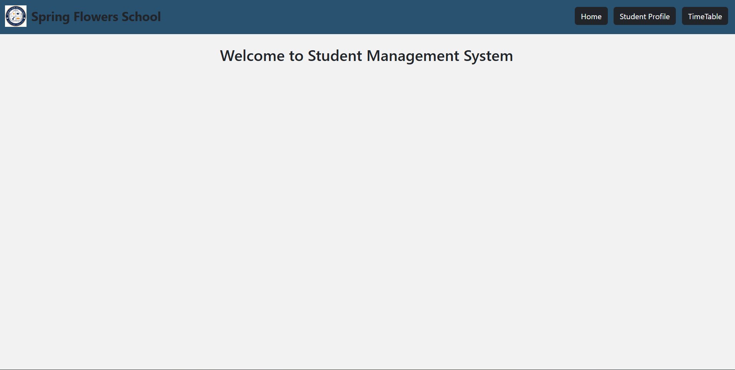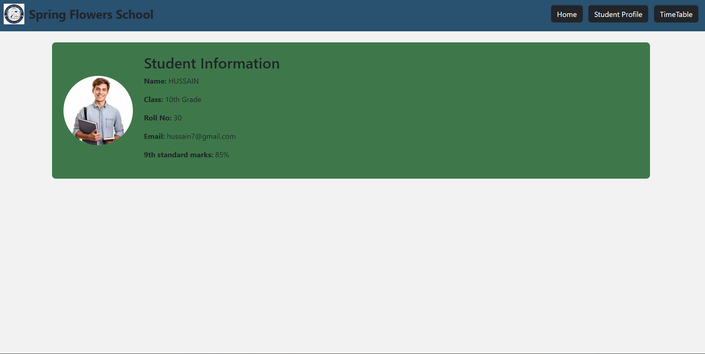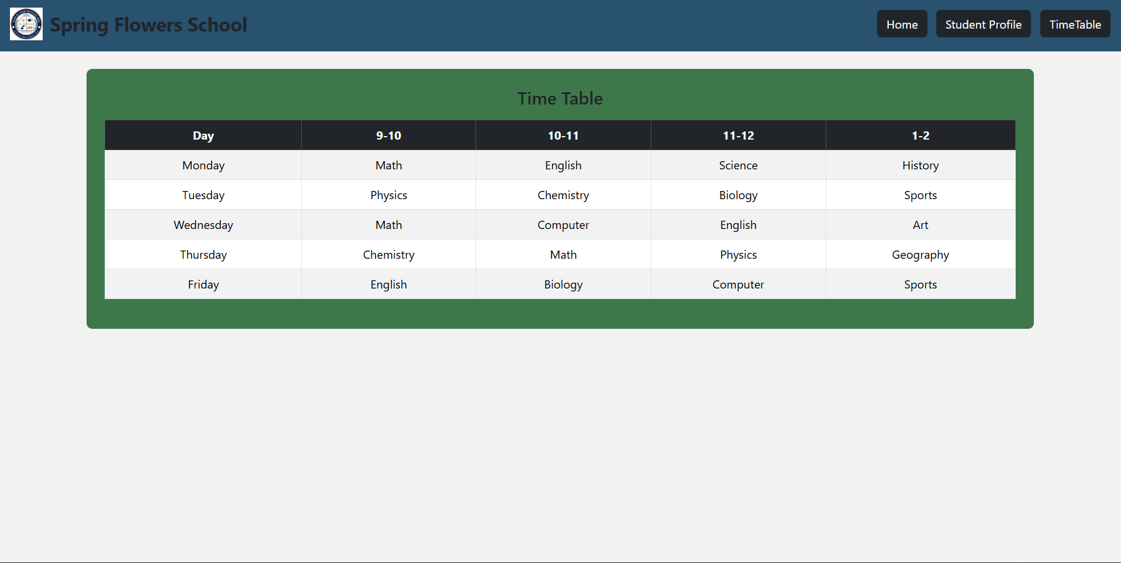
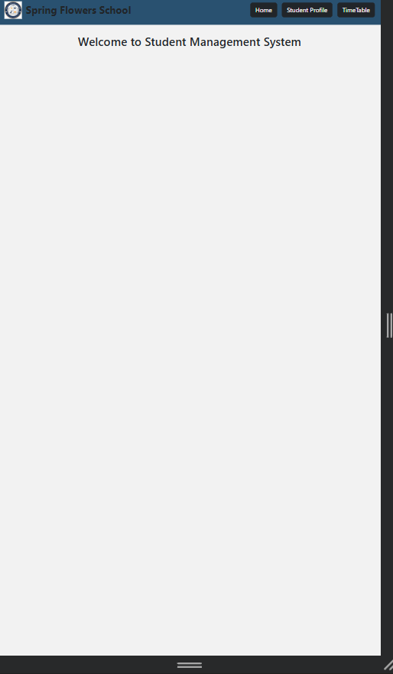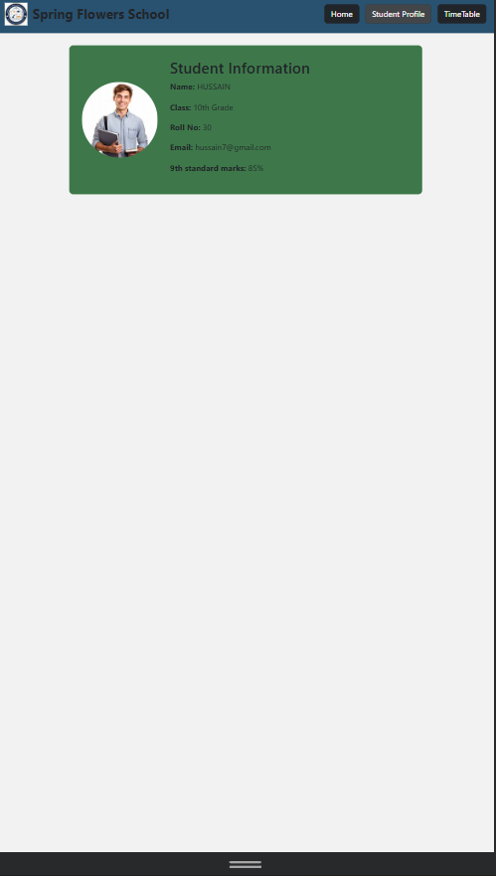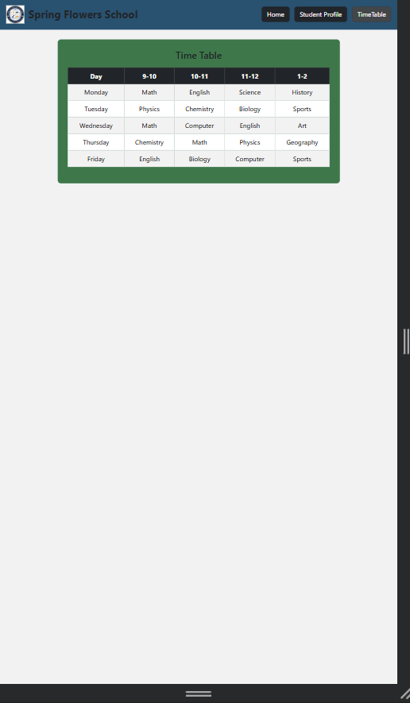
Mobile View

